
Cranleigh House
191 Prestbury Road | Cheltenham | GL52 3ES
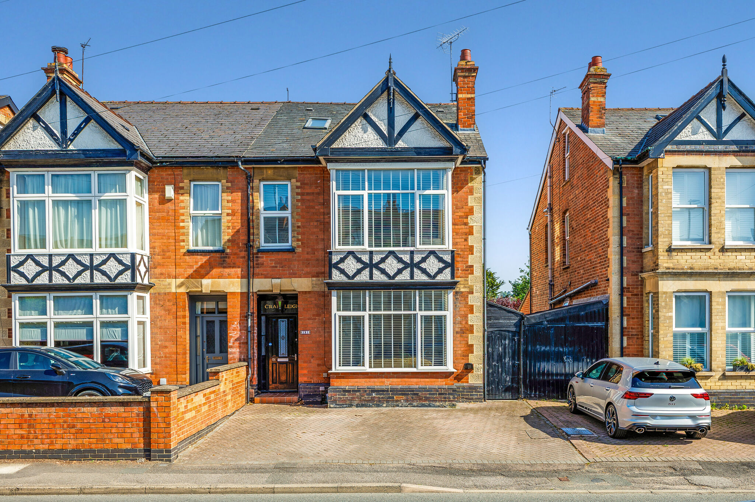

Ground floor
- Reception hall
- Sitting room
- Kitchen/dining/family room
- Cloakroom
- Utility room
- Access to patio and garden

First floor
- Principal bedroom with ensuite shower room
- Two further bedrooms
- Family bathroom

Second floor
- Two further bedrooms
- Further bathroom

Outside
- Private garden with patio area
- Summer House
- Driveway with private parking and storage area

Location
Occupying a highly convenient position on the ever-popular Prestbury Road, the property is perfectly placed for both Cheltenham town centre and the beautiful Pittville Park. A wide range of independent cafés, shops and restaurants are within easy reach, along with highly regarded schools and the historic Cheltenham Racecourse. The A40 and M5 are all easily accessible, providing excellent links to Gloucester, Oxford, Birmingham and beyond.

Cranleigh House
Prestbury Road, Cheltenham, GL52 3ES

BEAUTIFULLY RENOVATED, CRANLEIGH HOUSE IS AN ELEGANT FIVE BEDROOM SEMI-DETACHED FAMILY HOME ON PRESTBURY ROAD, JUST MOMENTS FROM THE HEART OF PRESTBURY. THOUGHTFULLY DESIGNED FOR MODERN FAMILY LIVING, IT OFFERS WELL-BALANCED ACCOMMODATION THROUGHOUT, A WONDERFUL SOUTH-FACING GARDEN AND GENEROUS OFF-ROAD PARKING.

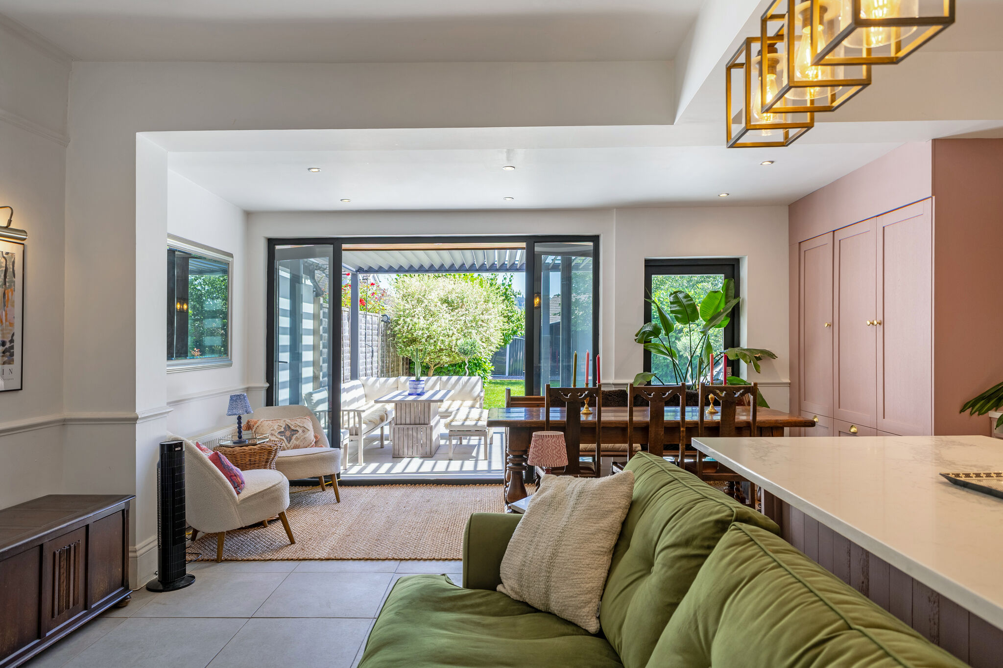

The Property

A welcoming entrance hall with wooden flooring leads to a beautifully proportioned reception room, where original floorboards, a period feature fireplace and an attractive bay window create a warm and inviting space full of character.
To the rear, the heart of the home is a superb open-plan kitchen, dining and family room, thoughtfully designed for modern living. Featuring a central island with marble worktops and seating, a range-style cooker, a cosy snug area and a separate utility room, this impressive space opens directly onto the south-facing garden.
The first floor offers three well-appointed bedrooms, including a generous principal suite with a bay window and contemporary en-suite shower room, together with a stylish family bathroom. The second floor provides two further double bedrooms, an additional bathroom and a useful study area, creating a flexible space ideal for growing families or those working from home.

Outside, the property benefits from a private driveway providing off-road parking for two cars, along with a useful storage area complete with lighting and an outdoor power socket.
Designed for both relaxation and entertaining, the beautifully landscaped south-facing garden features generous seating areas, mature planted borders and a charming summer house.
Further enhancing the property’s appeal are a number of practical improvements, including the installation of solar panels to improve energy efficiency and a newly fitted boiler in 2021, ensuring the home is as efficient as it is beautifully presented.

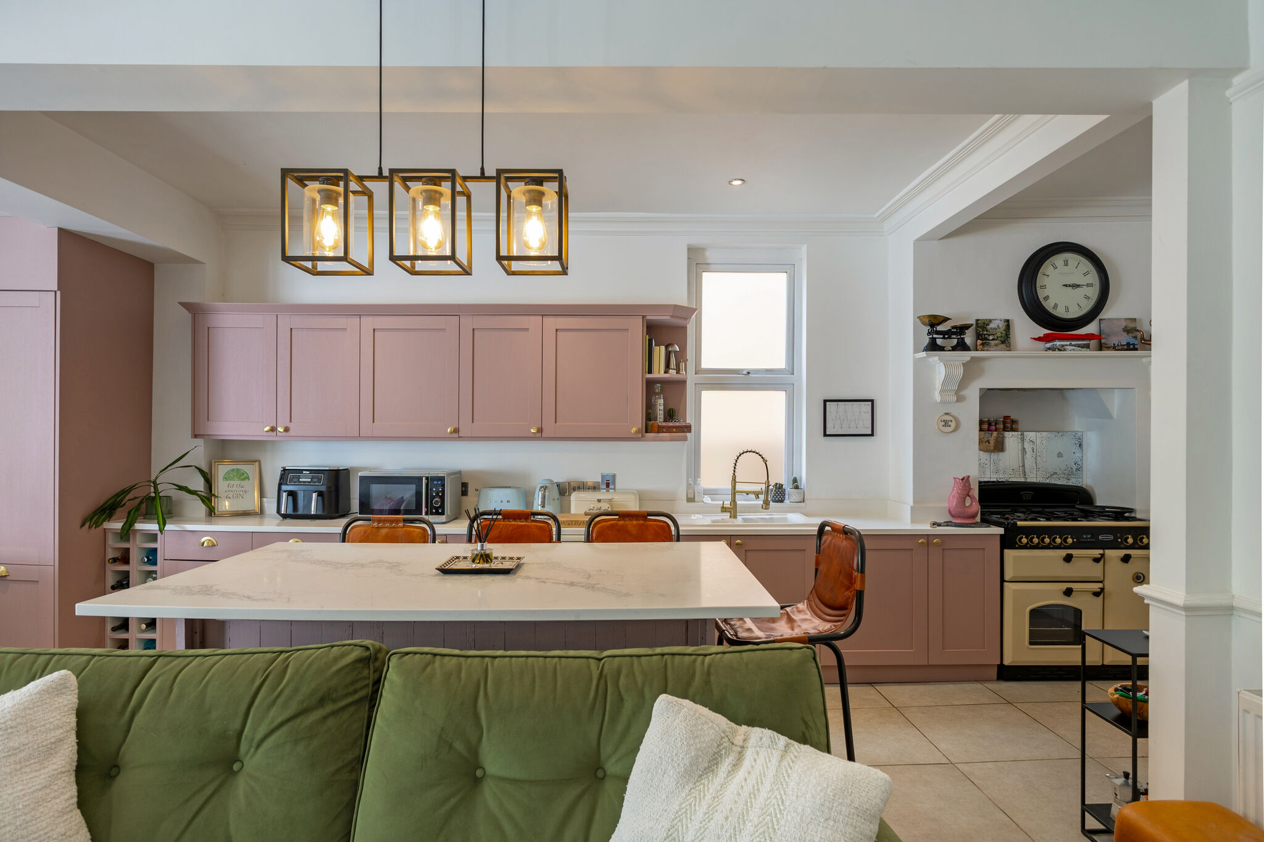
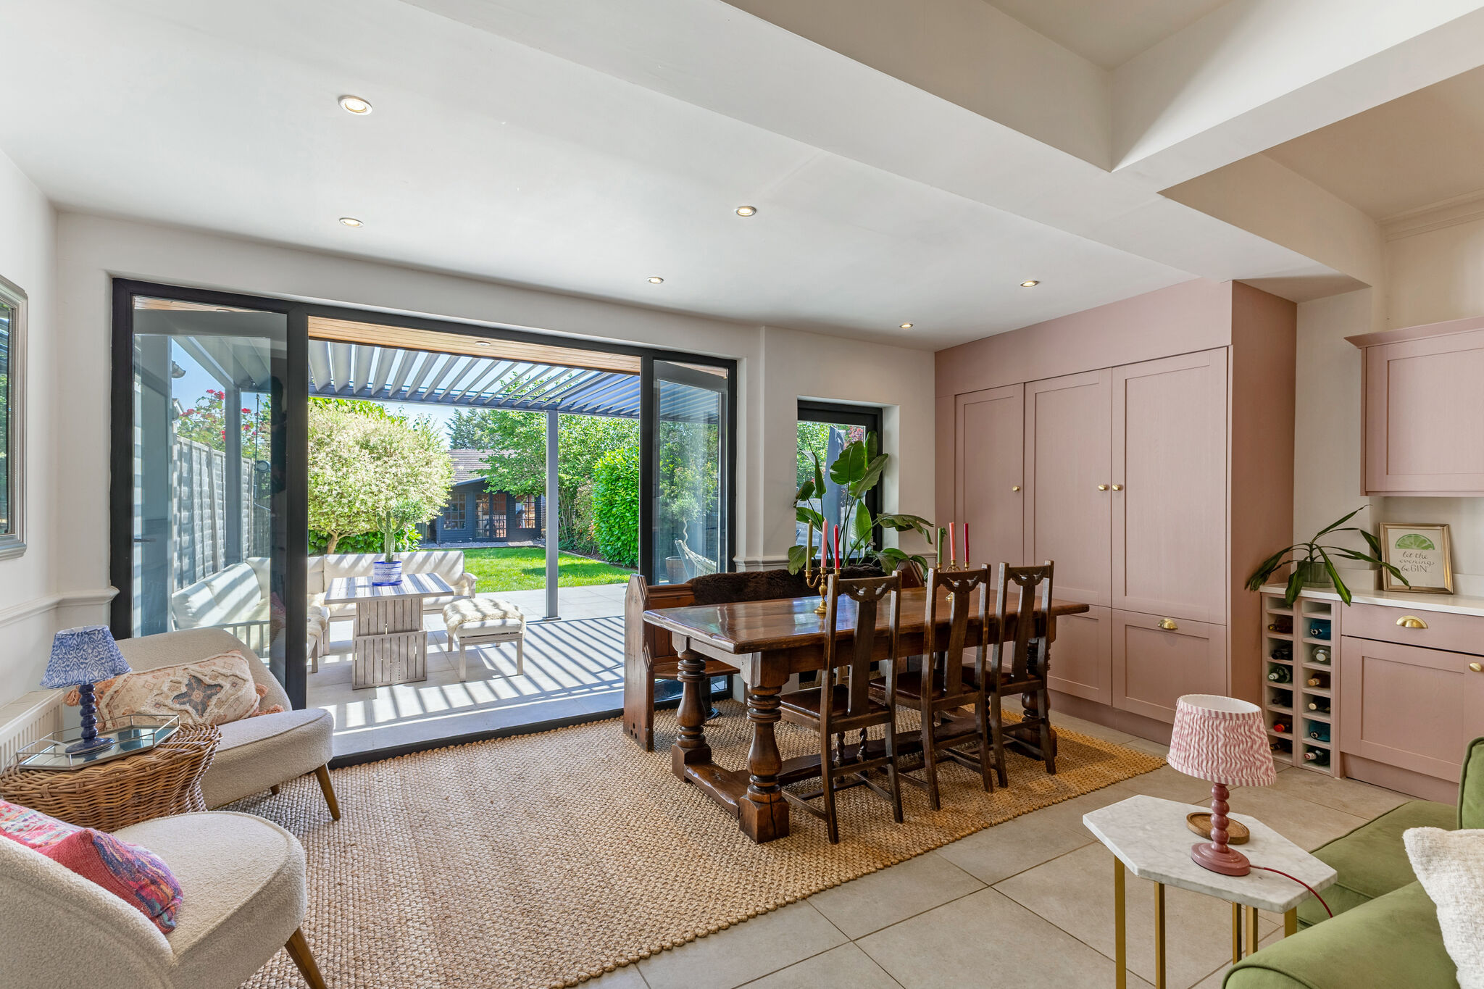
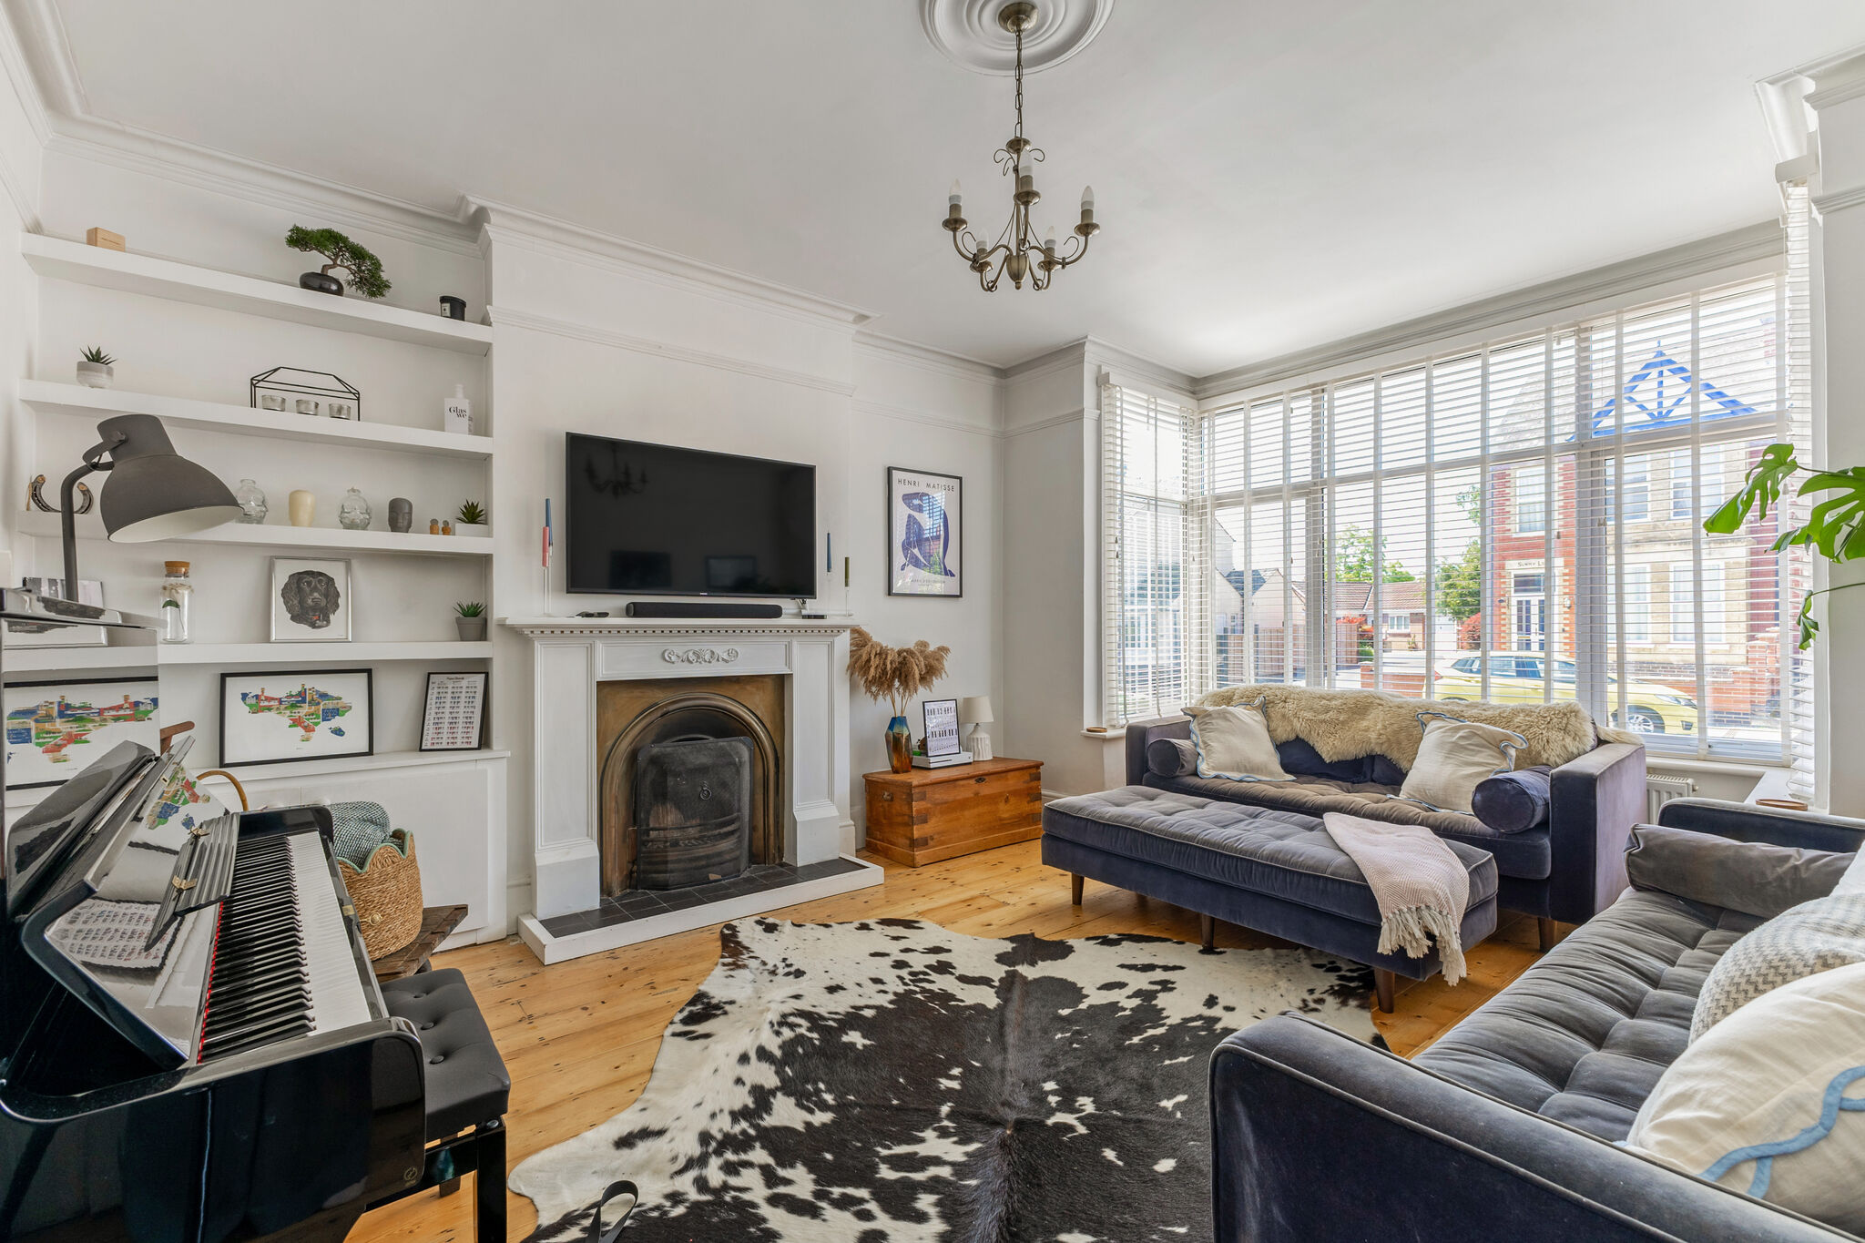
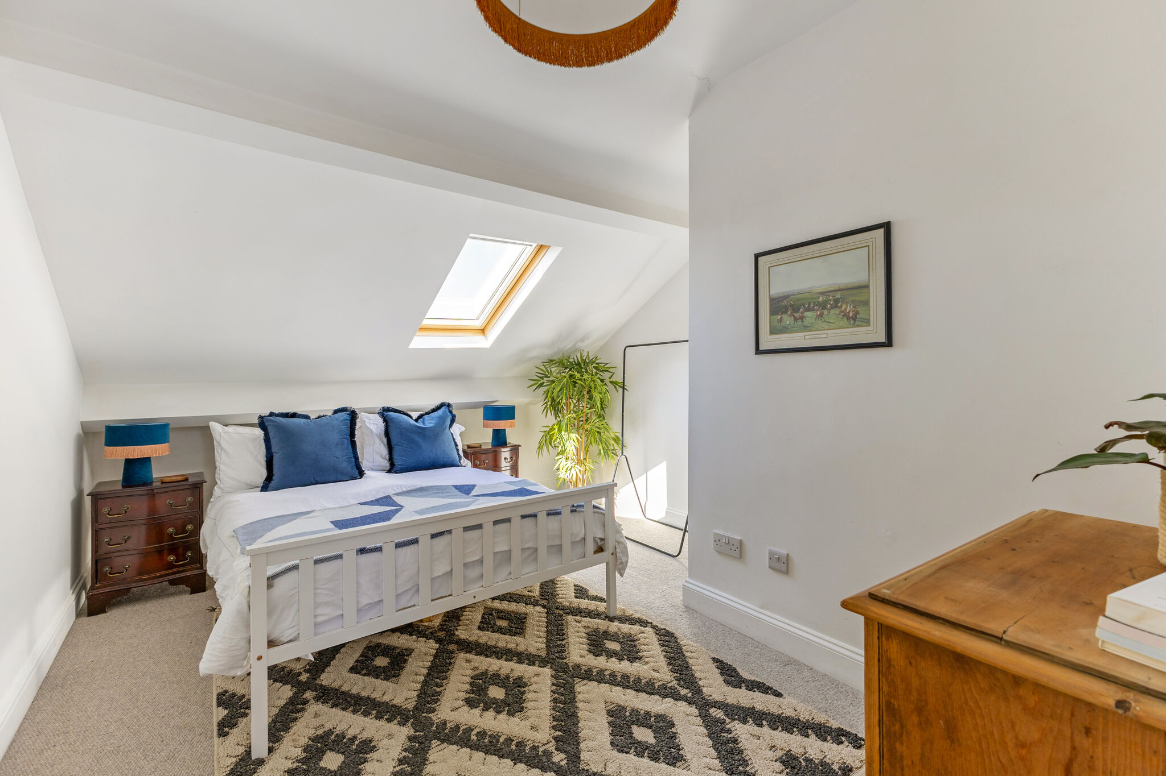
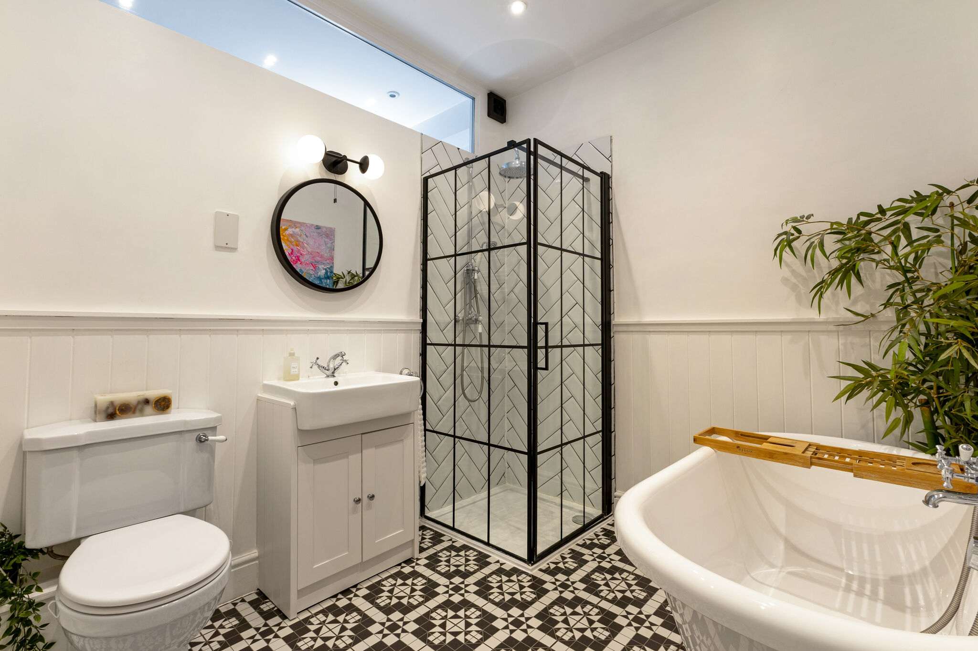
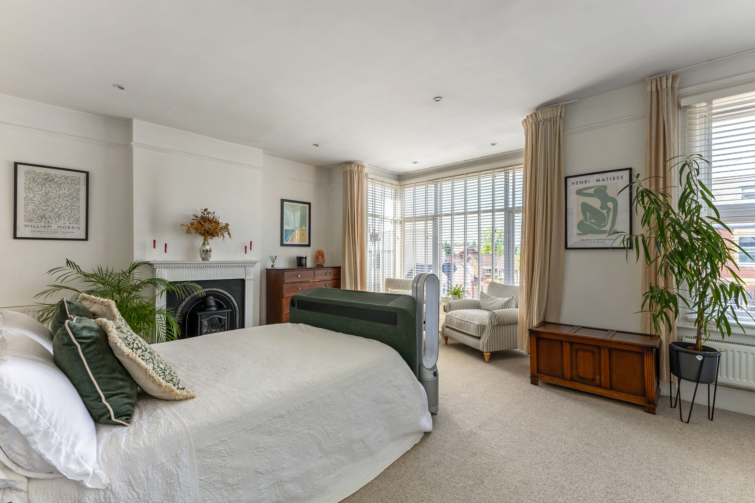
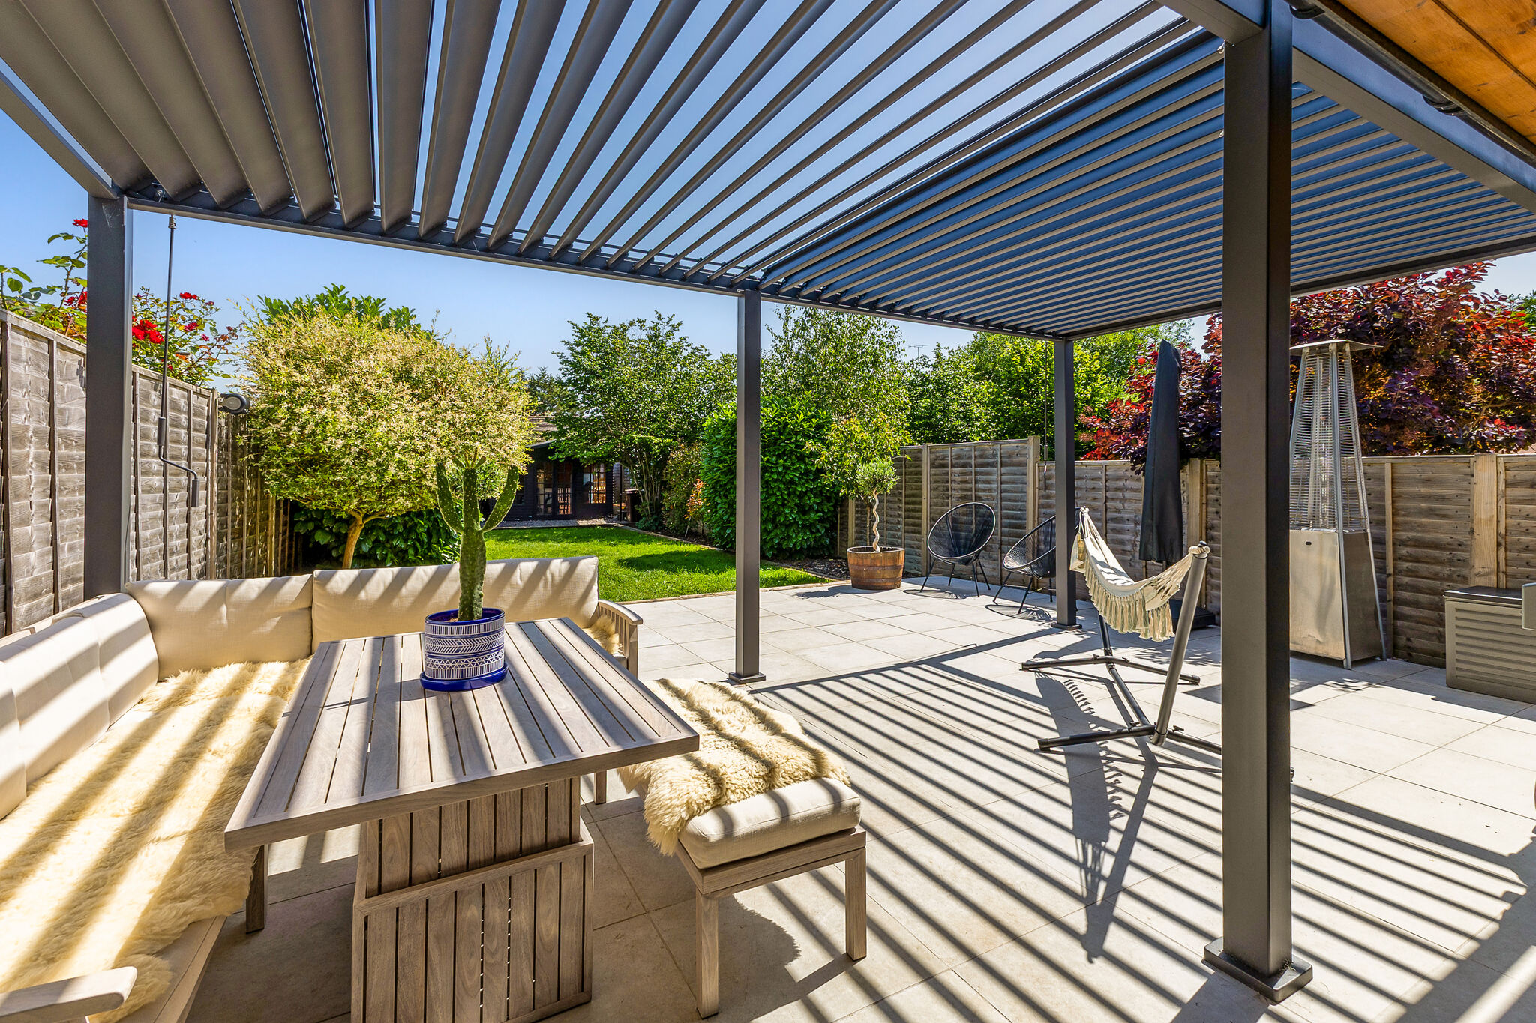
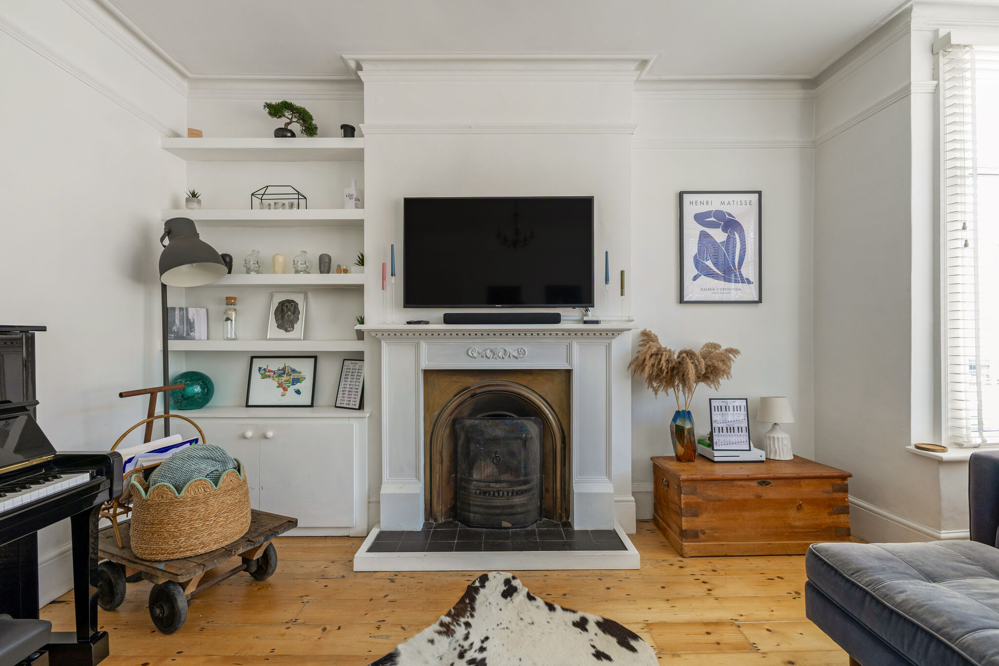
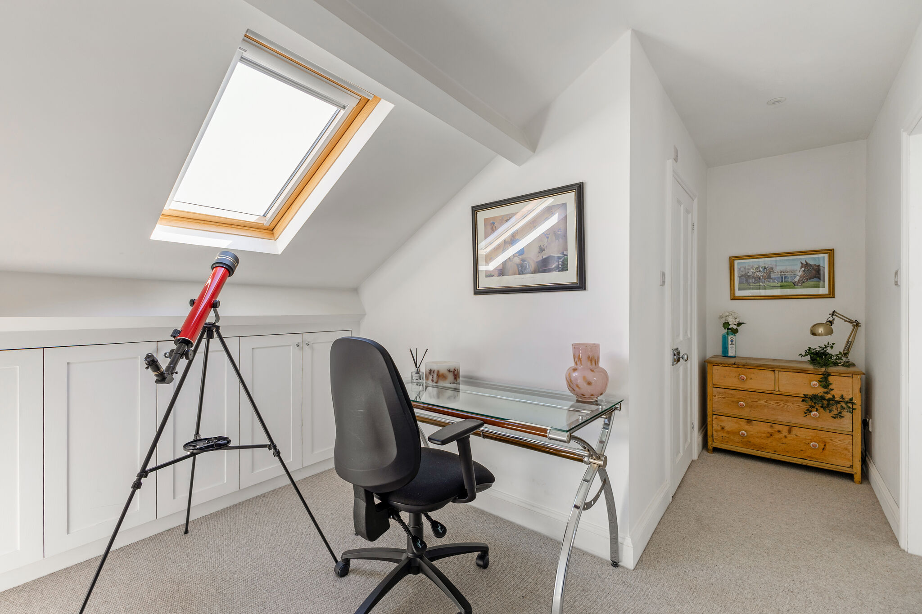
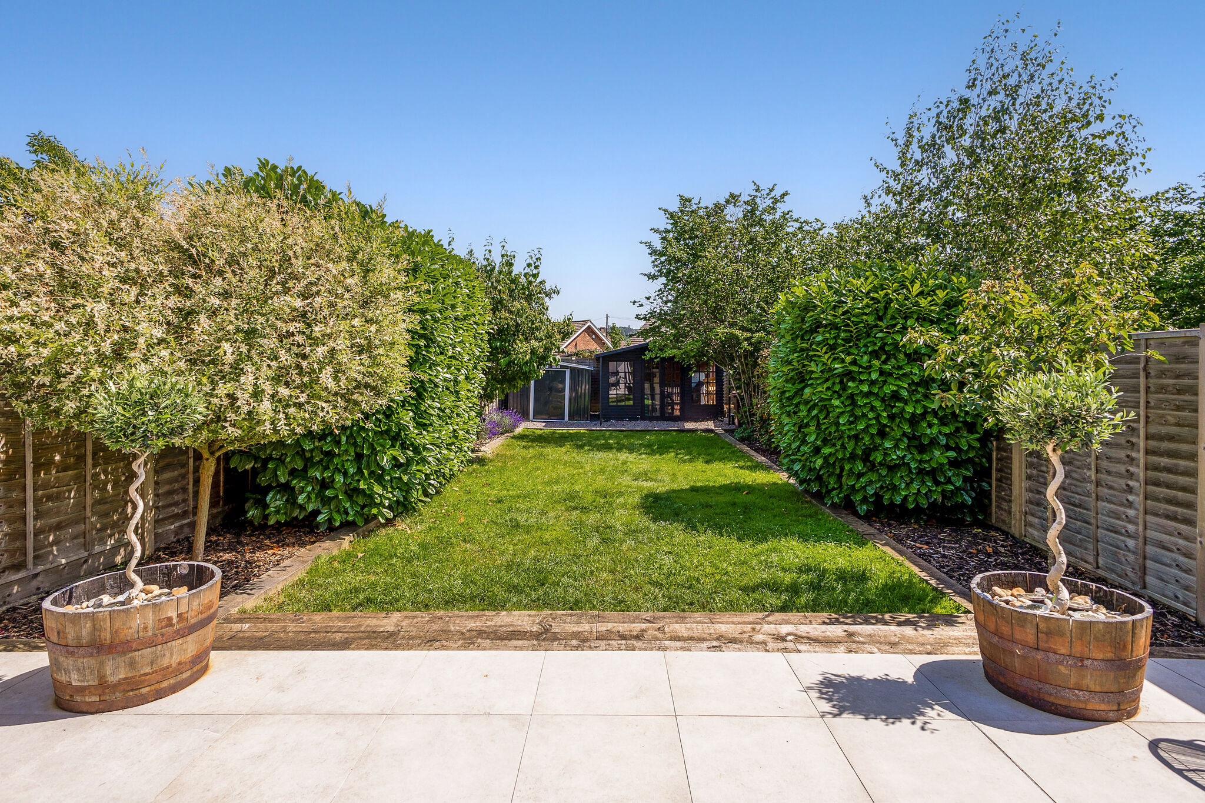





hello@laagency.co.uk
01242 500 404
laagency.co.uk
The Limes, Bayshill Road, Cheltenham GL50 3AW
